Annex 1
Race Map
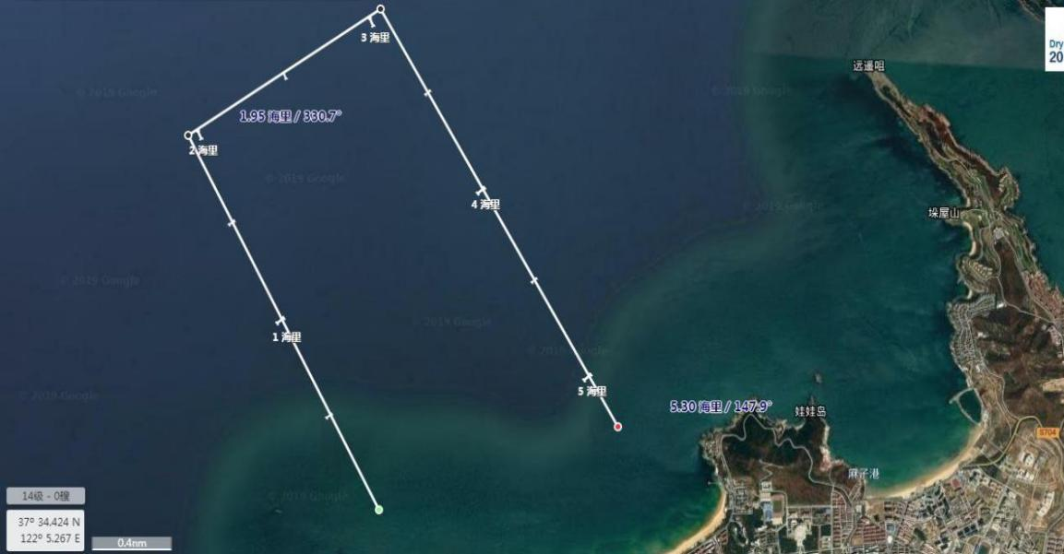
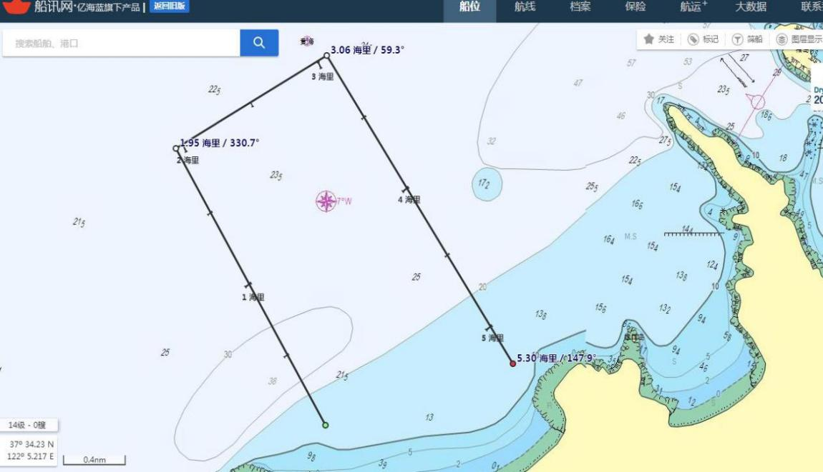
Reference coordinate
- N 37°33.738 3. N 37°34.054
E 122°00.309 E 122°01.251
- N 37°31.889 4. N 37°32.217
E 122°01.318 E 122°02.415
(Note: Long voyage experience course will be released separately during the captain's meeting)
Annex 2
Team Entry Form
Class |  |  |  | Sailboat | Rent/Bring own boat
Position | Skipper | Name |  |  | Gender
Nationality |  | Date of Birth  (yyyy/mm/dd) |  |  | Weight | KG
Certificate Type |  |  |  | ID Number
Healthy Condition |  |  | Description | (Fill in blood type, allergy history or other important information)
Working Organization & Position |  |  |  | E-mail
Phone Number |  |  |  | Emergency Contact Person&  Phone number
Race experience and results:

Position | Trimmer | Name |  |  | Gender
Nationality |  | Date of Birth  (yyyy/mm/dd) |  |  | Weight | KG
Certificate Type |  |  |  | ID Number
Healthy Condition |  |  | Description | (Fill in blood type, allergy history or other important information)
Working Organization & Position |  |  |  | E-mail
Phone Number |  |  |  | Emergency Contact Person&  Phone number
Race experience and results:

Other Information
Arrival Date&Time |  | Arrival  Airport/Station |  |  | Arrival  Flight/Rail NO.
Departure Date&Time |  | Departure Airport/Station |  |  | Departure Flight/Rail NO.
Room  Type&Number |  | Check-in  Date&Time |  |  | Check-out  Date&Time

